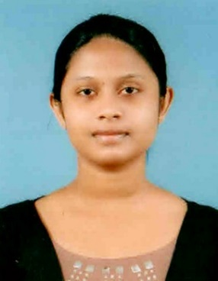

**J.M Piumi Thakshila**

Mobile Phone : **+94773 516471, +94772644320**

Email:[piumithakshilajm@gmail.com](mailto:piumithakshilajm@gmail.com)

Permanent Address: **Dunakadeniya, Welipennagahamulla.**

To find a gainful employment opportunity in a well recognized institution where I could further enhance my skills and experiences while employing my knowledge productively for my employer and to obtain a challenging position that will allow me to expand upon my education and continue to accumulate knowledge and experience.

***Career Objective***

* **The Institute of Chartered Accountants of Sri Lanka (ICASL)**

***Professional***

***Qualifications***

Completed the Certificate in Accounting and Business I

* **Institute of personal Management Sri Lanka (IPM)**
* Successfully completed the Foundation Course in HRM- FCHRM
* Successfully completed the Certificate Course in HRM - CCHRM
* Following Professional Qualification in HRM – PQHRM (Stage II)
* **ISK Education Institute - Kuliyapitiya**

Successfully Completed the Basic English Course

***Working Experience***

* **HR Intern**

Seylan Bank PLC (August 2015 –February 2016)

* **Accounts Assistant**

Earthscape (PVT) Ltd (June 2015 -August 2015)

* **Project Officer**

Senova Multy System Solution (PVT) Ltd (June 2014-June 2015)

* **KP/ Central College, Kuliyapitiya**

***Academic Qualifications***

**G.C.E Advanced Level- 2012 (Index No: 5322391)**

Business Studies **B**

Economics **B**

Accounting **C**

Z-Score **0.3475**

* **KP/ Holy Angles Girls’ School, Kuliyapitiya**

***Personal Profile***

**G.C.E. Ordinary Level Examination - 2008 (Index No: 81565372)**

Buddhism **A** Drama & Theatre **A**

Lang. & Lit (S) **A** Business Std. Accounting A

Health & phy. Education **A** History **B**

Mathematics **C** English **C**

Science & Technology **C**

* Diploma in Computerized Accounting in JMC Institute.

***Computer Skills***

(Quick Books Pro)

* Sound knowledge in MS Word, Excel, PowerPoint, Access .
* Hands on experience with E-mail and Internet applications.
* Certificate Course in Computer Literacy & Computer Study.

* Member of Sri Lanka Red Cross Society.

***Certificates & Awards***

* Inter House Sports Meet- 2011, 2nd Runner up in Netball under 21st Girls.
* English Week Competitions-2004, 1st Place in School Level Group Singing.
* Member of the Commerce Society in Central College, Kuliyapitiya. (2010/2011)

***Personal Details***

Full Name : Jayamanna Mohottalalage Piumi Thakshila

Date of birth : 21st September 1992

Sex : Female

Marital status : Single

N.I.C no : 927650223V

Nationality : Sri Lankan

Religion : Buddhism

Languages known : English, Sinhala

Mr. Robinson Fernando Dr. C.R Sandamali Fernando

***Non Related Referees***

Retired Branch Manager District Hospital

Ceylinco Insurance Makandura

Naththandiya Gonawila (NWP)

071-3283571 077-7994116

I truly and sincerely attest that the above information furnished by me, are true and accurate to the best of my knowledge, and shall be pleased to present myself for a hearing from you.

Date: ………. /………. /………….. .……..………………………..

J.M.P.T Jayamanna